Restaurant Review: Matanza in Nob Hill
By Aja Simpson

In the heart of Nob Hill sits a relatively new, local and unique take on the flavors of New Mexican cuisine and culture.

As a sit-down restaurant in the price range above that of any UNM student, it’s marketed as a “New Mexico Local Craft Beer Kitchen”. It’s easy to see that it is a stark contrast to the Kelly’s Diner that sits across the street, a place best known for their casual outside seating and sports bar appetizers.
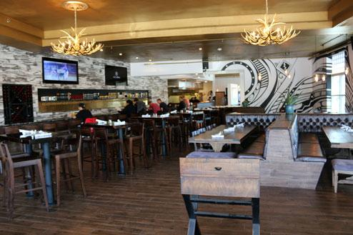
Large windows encapsulate the space and their impressive lineup of nearly 80 local beers on tap are the first thing on display through the front door. The dimly lit antler chandeliers combined with the dark wooden furniture and fake marble backsplash behind the bar add a modern and sleek element. It has definitely taken on the trendy vibes that Urban Outfitters gives off one door over.

That modernity follows over to their menu. It’s New Mexico inspired but not at all traditional in terms of format and pricing. Think of a more upscale version of Blue Corn Cafe in Santa Fe and that’s Matanza.. They specialize in crispy and textured flatbread, flavorful and sweat-inducing “sangwiches” (no really, check the menu) and a huge array of chile-infused meals.
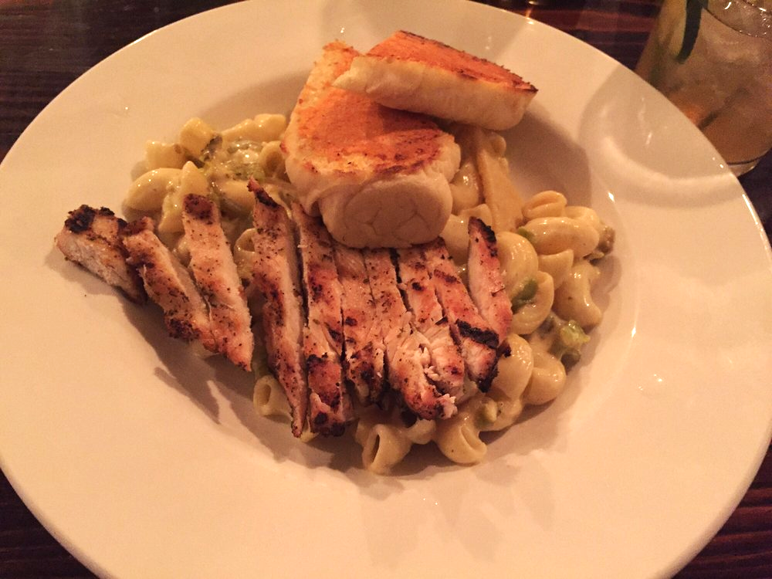
Different from, but just as intriguing as, all of the upscale mexican dishes and those mentioned above is the “Grown-up Mac and Cheese Skillet”. Havarti, white cheddar and monterey jack, melted together seamlessly, leave the chiferri noodles smooth and creamy. On top of that, green hatch chile to counteract the cheese-medley and a healthy heaping of grilled chicken, still steaming as it came out of the kitchen.

Cut the chicken into bite-sized pieces and be sure to take as many fork-fulls of the mac and meat at the same time. The combination of flavors is so simple yet so unknown to the childhood version of this famous dish. The only problem here was the 2 pieces of bread thrown on top of the plate: the cheese melted over top is too crusty and the bread is too chewy to enjoy. Don’t bother.

Many people come to this restaurant for the filling variety of flatbread, an item on the menu that won’t break the bank but will still satisfy in quantity and quality. The martineztown has all the best elements of a flatbread, but amplified. The crust is crunchy and buttery in all the right places, the cheese (havarti) doesn’t overwhelm the palette and the meat (wild-boar sausage) is exceptionally juicy.

Matanza is the spot for Burqueño’s who love the tastes from their home state but want to try something different, while still enjoying the comfort of green chile and all the local alcohol they can afford.

Take a lover you want to impress, a group of people to share a few dishes and drinks, or enjoy it after a special event with family.

